

**Dinero: Horse of the Force**

**Is a short Digital Story about how Dinero, from the Kentucky Horse Park became a Mounted Police horse.**





**Dinero: Horse of the Force**

**Is a short Digital Story about how Dinero, from the Kentucky Horse Park became a Mounted Police horse.**





**Dinero: Horse of the Force**

**Is a short Digital Story about how Dinero, from the Kentucky Horse Park became a Mounted Police horse.**





Is a Short Graphic Novel of how to read horse body language, with bright colorful pictures and a ton of information.

**Can you Read Me?**

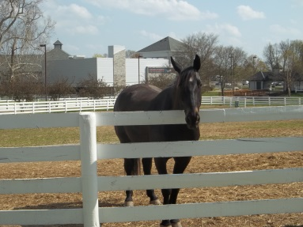



Is a Short Graphic Novel of how to read horse body language, with bright colorful pictures and a ton of information.

**Can you Read Me?**





Is a Short Graphic Novel of how to read horse body language, with bright colorful pictures and a ton of information.

**Can you Read Me?**

